USN NUMBER:1RUA24CSE0122

NAME:Dhanush D

|  |  |
| --- | --- |
| **Ex No: 8**  **Date: 24-10-2025** | **KNN classification** |

**1.Objective:**

To classify handwritten digits (0–9) from the **Digits dataset** using the **K-Nearest Neighbors (KNN)** algorithm and determine the best value of *K* that gives maximum accuracy.

**2. Descriptions:**

**The notebook uses the sklearn.datasets.load_digits() dataset, which contains 8×8 grayscale images of handwritten digits.**

**Workflow:**

1. **Load dataset using load_digits()**
2. **Visualize samples of digits**
3. **Split into training and testing data**
4. **Train KNN model with various k values (1–20)**
5. **Find best K manually and with GridSearchCV**
6. **Evaluate the model using:**
   * **Confusion Matrix (via heatmap)**
   * **Classification Report (Precision, Recall, F1)**
   * **Overall Accuracy**

**3. Model or Flowchart or Architecture**

USN NUMBER:1RUA24CSE0105

NAME:Chetan Jagannatha

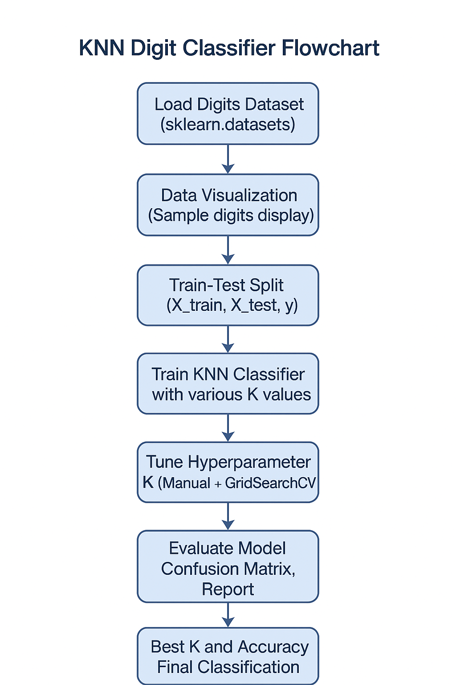

**4.Algorithm**

1. Input: Dataset with images of digits (64 features each).
2. Split: Train (80%) and Test (20%) sets.
3. Train: For each K (1 to 20):

-> Compute Euclidean distance between test and train samples.

->Select K nearest neighbors.

-> Assign the most frequent class among neighbors.

1. Optimize K:

->Use manual iteration and GridSearchCV to find the best K.

1. Predict: Classify new test images.

y ^ ​ =mode(y k nearest neighbors ​ )

1. Evaluate: Generate confusion matrix and classification report.

**5.GitHub Link:**

[**https://github.com/DhanushD1007/Datascience.git**](https://github.com/DhanushD1007/Datascience.git)